Question no 1:

#include<iostream>

#include<string.h>

using namespace std;

class Car{

string brand;

string model;

double rent;

bool available;

public:

Car()

{

brand="unknown";

model="generic";

rent=0.0;

available=true;

}

void setBrand(string b)

{

brand=b;

}

void setModel(string m)

{

model=m;

}

void setPrice(double p)

{

rent=p;

}

bool isAvailable()

{

return available;

}

void RentCar()

{

if(available)

{

available=false;

cout<<"THE CAR IS SUCCESSFULLY RENTED."<<endl;

}

else

{

cout<<"SORRY THE CAR IS NOT AVAILABLE FOR RENT"<<endl;

}

}

void display()

{

cout<<"=============================="<<endl;

cout<<" BRAND: "<<brand<<endl;

cout<<" MODEL: "<<model<<endl;

cout<<" PRICE:$ "<<rent<<endl;

cout<<"==================================="<<endl;

if(available)

{

cout<<"THE CAR IS AVAILABLE FOR RENT"<<endl;

}

else{

cout<<"CAR NOT AVAILABLE"<<endl;

}

cout<<"====================================="<<endl;

}

};

int main()

{

Car c1;

int a;

c1.display();

c1.setBrand("HONDA");

c1.setModel("LATEST");

c1.setPrice(1000000.00);

c1.display();

if(c1.isAvailable())

{

cout<<"DO YOU WANT TO RENT A CAR (0 or 1)?"<<endl;

cin>>a;

if(a==1)

{

c1.RentCar();

c1.display();

}

else

cout<<"WRONG INPUT PLEASE TRY LATER."<<endl;

}

}

Output:

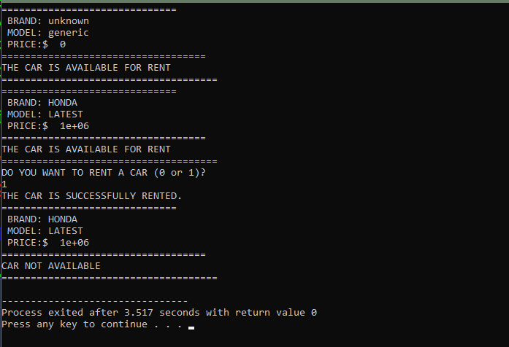

Question no 2:

#include <iostream>

#include <string>

using namespace std;

class Car {

string brand;

string model;

double rent;

bool availability;

public:

Car(string b, string m, double r, bool a) {

brand = b;

model = m;

rent = r;

availability = a;

}

Car() {

brand = "unknown";

model = "unknown";

rent = 0.0;

availability = false;

}

void applyDiscount() {

int n;

cout << "ENTER THE NUMBER OF DAYS YOU WANT TO RENT THE CAR FOR: ";

cin >> n;

if (n == 5) {

rent \*= 0.95;

cout << "THE PRICE AFTER 5% DISCOUNT IS: $" << rent << endl;

} else if (n == 10) {

rent \*= 0.90;

cout << "THE PRICE AFTER 10% DISCOUNT IS: $" << rent << endl;

} else {

cout << "DISCOUNT UNAVAILABLE." << endl;

}

}

bool isAvailable() {

return availability;

}

void RentCar() {

if (availability) {

availability = false;

cout << "CAR HAS BEEN RENTED." << endl;

} else {

cout << "SORRY, CAR IS NOT AVAILABLE." << endl;

}

}

void display() {

cout << "\n======= CAR DETAILS =======" << endl;

cout << "Brand : " << brand << endl;

cout << "Model : " << model << endl;

cout << "Rent : $" << rent << endl;

cout << "Availability: " << (availability ? "Available" : "Not Available") << endl;

cout << "============================\n" << endl;

}

};

int main() {

Car c1("HONDA", "CIVIC 2024", 1000.00, true);

c1.display();

char choice;

cout << "DO YOU WANT TO RENT THIS CAR? (Y/N): ";

cin >> choice;

if (choice == 'Y' || choice == 'y') {

c1.RentCar();

} else {

cout << "CAR RENTAL CANCELED." << endl;

}

c1.display();

c1.applyDiscount();

return 0;

}

OUTPUT:

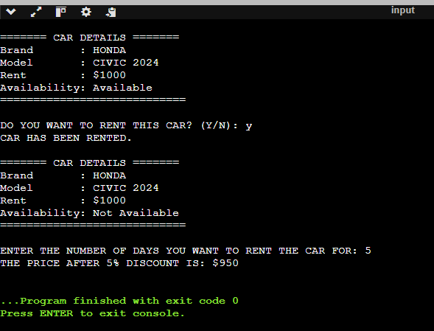

Question no 3;

#include <iostream>

#include<string.h>

using namespace std;

class Car {

public:

string brand;

string model;

double rent;

Car(string b, string m, double r) {

brand = b;

model = m;

rent = r;

}

Car(const Car &c) {

brand = c.brand;

model = c.model;

rent = c.rent;

}

~Car() {

cout << "Car " << brand << " " << model << " is removed from memory.\n";

}

void displayCar() {

cout << "Brand: " << brand << ", Model: " << model

<< ", Rent: $" << rent << endl;

}

};

int main() {

Car car1("Toyota", "Corolla", 1500.00);

cout << "Original Car:\n";

car1.displayCar();

Car car2 = car1;

cout << "\nCopied Car:\n";

car2.displayCar();

car1.brand = "Honda";

car1.model = "Civic";

car1.rent = 1800.00;

cout << "\nAfter Modifying Original Car:\n";

car1.displayCar();

cout << "\nChecking Copied Car After Modification of Original:\n";

car2.displayCar();

return 0;

}

OUTPUT:

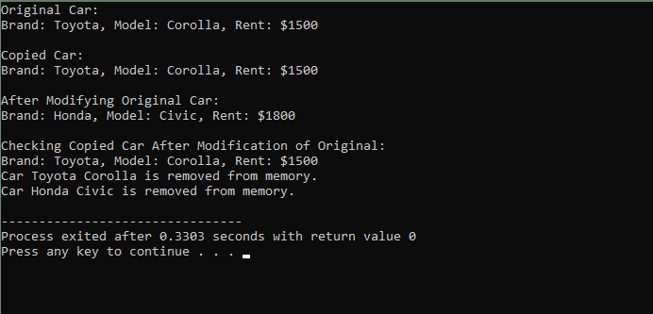

QUESTION NO 4:

#include <iostream>

using namespace std;

class Car {

private:

string brand;

string model;

double rent;

bool availability;

double totalRevenue;

public:

Car(string b, string m, double r) {

brand = b;

model = m;

rent = r;

availability = true;

totalRevenue = 0.0;

}

void rentCar(int days) {

if (availability) {

double revenue = rent \* days;

this->totalRevenue += revenue;

this->availability = false;

cout << "Car rented for " << days << " days. Revenue: $" << revenue << endl;

} else {

cout << "Car is not available for rent.\n";

}

}

void returnCar() {

this->availability = true;

cout << "Car returned and is now available.\n";

}

void displayCar() {

cout << "Brand: " << brand << ", Model: " << model

<< ", Rent: $" << rent << ", Revenue: $" << totalRevenue

<< ", Availability: " << (availability ? "Yes" : "No") << endl;

}

};

int main() {

Car car1("Toyota", "Corolla", 1000.00);

car1.displayCar();

car1.rentCar(3);

car1.displayCar();

car1.returnCar();

car1.displayCar();

car1.rentCar(5);

car1.displayCar();

return 0;

}

OUTPUT:

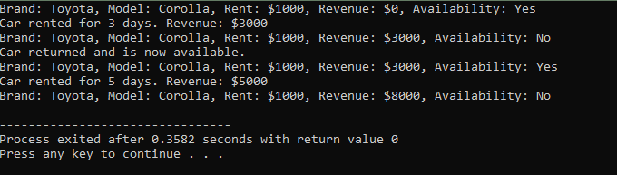

QUESTION NO 5:

#include <iostream>

using namespace std;

class Car {

private:

string brand, model;

double rent, totalRevenue;

bool availability;

string carID;

public:

Car(string id, string b, string m, double r)

: carID(id), brand(b), model(m), rent(r), availability(true), totalRevenue(0.0) {}

void rentCar(int days) {

if (availability) {

totalRevenue += rent \* days;

availability = false;

cout << "Car " << carID << " rented for " << days << " days. Revenue: $" << rent \* days << endl;

} else {

cout << "Car " << carID << " is not available.\n";

}

}

void returnCar() {

availability = true;

cout << "Car " << carID << " returned and is now available.\n";

}

void displayCar() {

cout << "ID: " << carID << ", Brand: " << brand << ", Model: " << model

<< ", Rent: $" << rent << ", Revenue: $" << totalRevenue

<< ", Availability: " << (availability ? "Yes" : "No") << endl;

}

};

int main() {

Car car1("C123", "Toyota", "Corolla", 1000.00);

car1.displayCar();

car1.rentCar(3);

car1.displayCar();

car1.returnCar();

car1.displayCar();

car1.rentCar(5);

car1.displayCar();

return 0;

}

OUTPUT:

